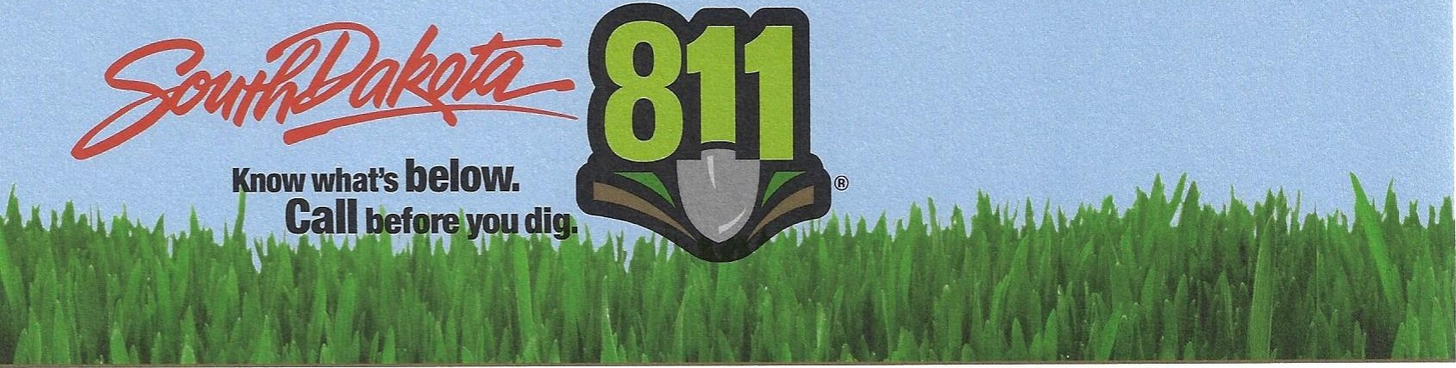
September 27, 2022
Mr. Dan Kaiser
Mr. Dan Kaiser
1200 S Kevin Circle
Sioux Falls, South Dakota 57106

Midco Communications
3901 N Louise Ave
Sioux Falls, South Dakota 57107

Re: OC22-004 B Mr. Dan Kaiser vs. Midco Communications
Under the authority granted by SDCL-49-7A-22, the Enforcement Panel of the South Dakota One Call Notification Board met on August 16, 2022 to determine whether there is probable cause to believe a One Call violation occurred in Complaint Docket OC22-004 B. The Enforcement Panel’s findings are enclosed. You may request a hearing according to SDCL-49-7A-27, if you disagree with the Enforcement Panel findings. If you do request a hearing you must be represented by legal counsel at the time you present your case to the One Call Board.

Failure to respond to this notice or request a hearing is considered acceptance of the Enforcement Panel Recommendation. In that case, the Recommendation will be Ordered by the South Dakota One Call Notification Board and your right to hearing is waived.

If you choose to request a hearing you must return the signed and dated form prior to the close of business on October 18, 2022.

South Dakota One Call Notification Board
PO Box 187
Rapid City, South Dakota 57709

Be aware, any future violations of any One Call statute or rule may be subject to additional penalties up to $10,000 for each subsequent violation that occurs within twelve months of the initial violation. If you have procedural questions relative to this complaint, please contact me at 605-863-0951 or by email at exedir@sdonecall.com . Do Not Contact any members of the South Dakota One Call Notification Board to discuss this complaint since members may be involved in a hearing if one is requested.

Cody M. Gregg

Cody M. Gregg
Deputy Director
South Dakota One Call

REQUEST FOR A HEARING
COMPLAINT OC22-004 B

I REJECT THE PANEL RESOLUTION TO COMPLAINT OC22-004 B AND REQUEST A HEARING.

_________________________________ ___________
Signature – Mr. Dan Kaiser Date

I REJECT THE PANEL RESOLUTION TO COMPLAINT OC22-004 B AND REQUEST A HEARING.

_________________________________ __________
Signature – Midco Communications Date

YOUR REQUEST FOR A HEARING MUST BE SENT TO ALL OTHER PARTIES INCLUDING:

SOUTH DAKOTA ONE CALL NOTIFICATION BOARD
PO BOX 187
RAPID CITY, SOUTH DAKOTA 57709

Failure to request a hearing will result in acceptance of the Enforcement Panel’s Recommendation by the South Dakota One Call Board. The Board will then Order the Recommendation as the final disposition of this Complaint.

